**(Software Architecture & Design) MEETING NOTES SHEET)**

**Team Members:**

* Keisha Geyrozaga (GEY23581805) – Product Owner
* Anderson Ricardo Gomes Ballesteroz (GOM21551647) – Scrum Master
* Clement Irivbeguai (IRI22514509) – Team Member
* Angelo Bongon (BON22529894) – Team Member

These meeting records serve to document key details of each team meeting conducted via Teams, including member attendance, communication with absent members, date and time, meeting format (in-person or online), objectives, and discussion summaries

**SPRINT 1**

**First Team Meeting**

**Meeting Notes**  
Our first team meeting was held on 26/01/2025 from 8:15 PM to 8:35 PM via Microsoft Teams. During the call, we discussed the team agreement, its content, and the signing process. We also reviewed the timesheet availability page, including how it can be updated weekly. Additionally, we covered the Code of Conduct and outlined the next steps for the team moving forward.

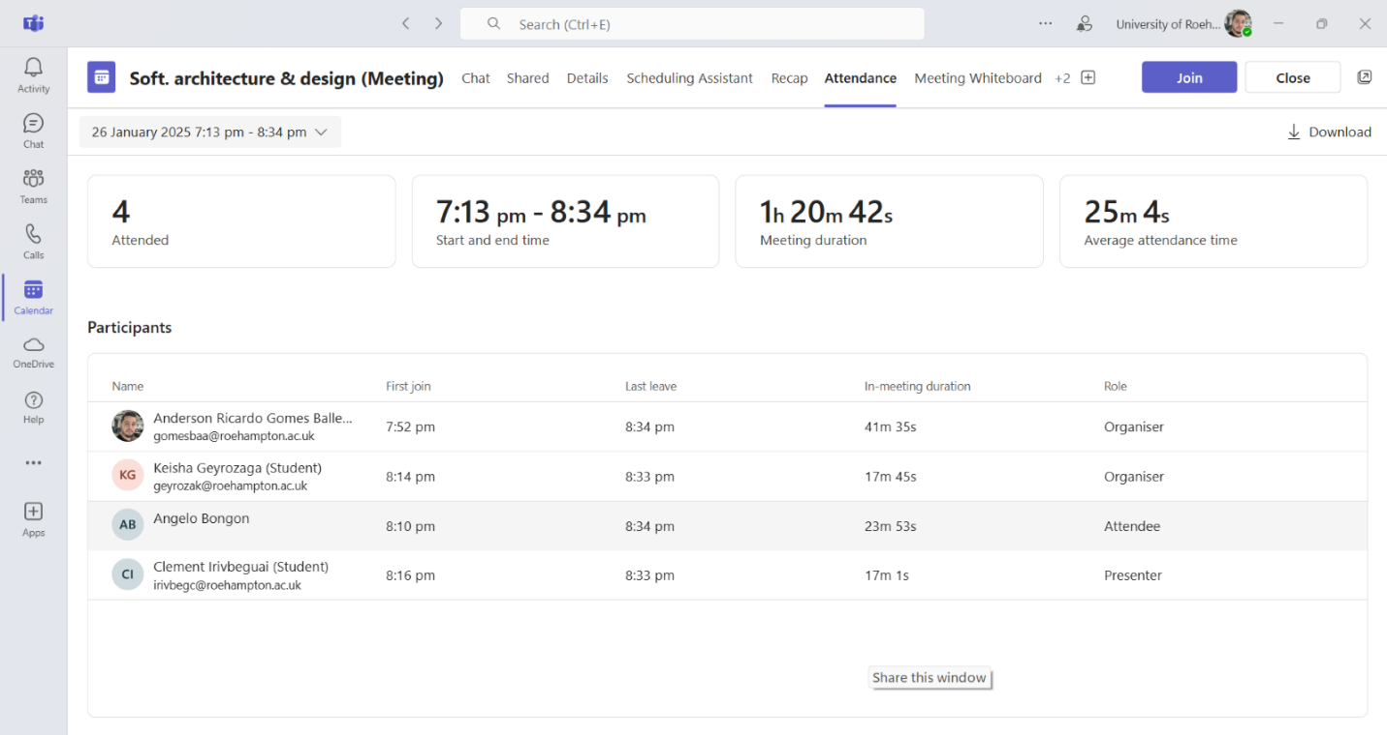

|  |  |
| --- | --- |
|  **| **First Team Meeting** (26/01/2025 22:10 - 20:15) |
| **Project Name** | Share price technical analysis |
| **Meeting Goal** | * Establish the foundation for the project by defining the team agreement, reviewing the Code of Conduct, and setting up essential tools for collaboration. * Discuss the timesheet availability and task allocation. |
| **Facilitator** | **Anderson Ricardo Gomes Ballesteroz** |
| **Note taker** | **Keisha Geyrozaga, Anderson Ricardo Gomes Ballesteroz** |
| **Attendees** | * Keisha Geyrozaga (GEY23581805) – Product Owner * Anderson Ricardo Gomes Ballesteroz (GOM21551647) – Scrum Master * Clement Irivbeguai (IRI22514509) – Team Member * Angelo Bongon (BON22529894) – Team Member |
| **Roundtable Updates (each group member to contribute)** | * **Keisha Geyrozaga:** Introduced the team agreement and explained its importance. * **Anderson Gomes:** Provided an overview of the timesheet availability and how it should be updated weekly. * **Angelo Bongon:** Explained the Code of Conduct and ensured all members agreed to sign it. * **Clement Irivbeguai:** Outlined the next steps, focusing on setting up project tools and defining architectural principles. |
| **Discussion points** | * **Team Agreement & Code of Conduct:** Finalized and signed. * **Timesheet Availability:** Agreed on how to update and maintain it. * **GitHub Repository:** Discussed the need to create branches and commit guidelines. * **Project Scope:** Identified key requirements for the Share Price Comparison Web Application. * **Next Steps:** Assign tasks for setting up tools and initial research. |
| **Actions (list tasks and assign a group member)** | * **(ANDERSON):** Set up Meeting Records format. * **(ANGELO):** Create the component diagram. * **(KEISHA):** Create & assign sprint 1 tasks to groupmembers. * **(KEISHA):** Define and finalize the Code of Conduct * **(KEISHA):** Set up GitHub repository and branches * **(KEISHA):** Identify and document project scope and requirements * **(CLEMENT):** Initialize Java project in IntelliJ |

**Second Team Meeting**

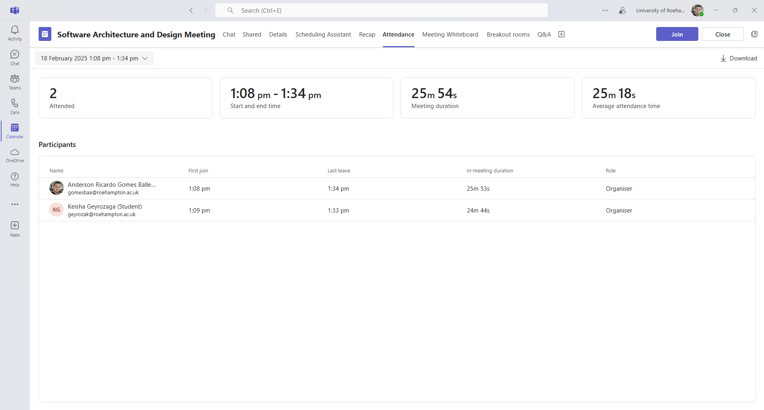

|  |  |
| --- | --- |
|  **| **Second Team Meeting** (18/02/2025 13:08 - 13:34) |
| **Project Name** | Share price technical analysis |
| **Meeting Goal** | * Ensure documentation is up to date and requirements are well defined. * Review project scope and task progress. |
| **Facilitator** | **Anderson Ricardo Gomes Ballesteroz** |
| **Note taker** | **Keisha Geyrozaga, Anderson Ricardo Gomes Ballesteroz** |
| **Attendees** | * Keisha Geyrozaga (GEY23581805) – Product Owner * Anderson Ricardo Gomes Ballesteroz (GOM21551647) – Scrum Master |
| **Roundtable Updates (each group member to contribute)** | * **Keisha Geyrozaga:** Reviewed project scope and ensured all requirements were correctly documented. * **Anderson Gomes:** Updated and organized meeting records. |
| **Discussion points** | * **Documentation Updates:** Ensured all files were correctly attached in the repository. * **Project Scope Review:** Verified alignment with coursework objectives. |
| **Actions (list tasks and assign a group member)** | * **(ANDERSON):** Update Meeting Records. * **(KEISHA):** Attach/update files in the repository. * **(KEISHA):** Finalize project scope document. |

**Third Team Meeting**

|  |  |
| --- | --- |
|  **| **Third Team Meeting** (18/02/2025 20:28 - 21:37) |
| **Project Name** | Share price technical analysis |
| **Meeting Goal** | * Finalize component diagram, Java implementation, and documentation. * Prepare for the final submission. |
| **Facilitator** | **Anderson Ricardo Gomes Ballesteroz** |
| **Note taker** | **Keisha Geyrozaga, Anderson Ricardo Gomes Ballesteroz** |
| **Attendees** | * Keisha Geyrozaga (GEY23581805) – Product Owner * Anderson Ricardo Gomes Ballesteroz (GOM21551647) – Scrum Master * Clement Irivbeguai (IRI22514509) – Team Member * Angelo Bongon (BON22529894) – Team Member |
| **Roundtable Updates (each group member to contribute)** | * **Keisha Geyrozaga:** Verified that all assigned documentation was correctly stored in the repository. * **Anderson Gomes:** Confirmed all meeting records were updated and reviewed. * **Angelo Bongon:** Completed the component diagram. * **Clement Irivbeguai:** Finalized the Java project structure and implemented key classes. |
| **Discussion points** | * **Component Diagram Completion:** Verified design accuracy. * **Code Implementation Review:** Ensured all basic functionality was implemented in Java. * **Final Documentation Check:** Confirmed all required files were present in the repository. |
| **Actions (list tasks and assign a group member)** | * **(ANDERSON):** Finalize Meeting Records * **(ANGELO):** Complete the component diagram * **(KEISHA):** Verify all documentation updates in GitHub * **(CLEMENT):** Write basic classes for stock data handling * **(CLEMENT):** Implement abstract code structure |